BLOOMINGDALE BOUROUGH BOARD OF HEALTH
REGULAR MEETING MINUTES – October 1, 2018

- Call to Order.
Ms. Petersen called the meeting to order at 7:33 p.m.

- Roll Call.
Present: Petersen, Innamorato, Reynolds, Carney and Fallon
Also Present: Gail Gratzel, Assistant Health Officer

- Approval of Minutes.
Motion was made by Ms. Carney to approve the August 6, 2018 minutes as presented. This motion was seconded by Ms. Innamorato and was unanimously approved.

- Acceptance of Reports
After discussion of the presented reports on motion by Ms. Fallon with a second by Ms. Carney the Health Department Monthly Report, Retail Food Inspection Summary Report, and Year to Date Report were approved as submitted and unanimously approved.

- Unfinished Business
Mayor’s Wellness Campaign: Ms. Gratzel reported that the Wellness Challenge was a success. The program was well received by the community and feedback from participants was very positive.
Stigma Free: Ms. Petersen reported that the Color Run took place last Sunday. No one from the BOH attended; there was no reporting on this event.
Bloomingdale Health Contract: Motion was made by Ms. Carney to approve Resolution of the Borough of Bloomingdale Board of Health authorizing an Interlocal Agreement between the Township of Pequannock and the Borough of Bloomingdale Board of Health for Public Health Services. This motion was seconded by Ms. Fallon and approved:
Ms. Carney – Aye
Ms. Fallon – Aye
Mr. Lovelace – Aye
Ms. Innamorato – Aye

- New Business
Ms. Petersen discussed the lack of responses to the meeting emails. Ms. Petersen articulated that board members should ‘respond to all’ by the Friday prior to the meeting as to whether or not they can attend.

- Public Discussion
Motion was made by Ms. Innamorato to open the meeting to public discussion. This motion was seconded by Ms. Carney and all voted in favor. As there was no public wishing to address the Board, motion was made by Mr. Lovelace to close the meeting to public discussion. This motion was seconded by Ms. Fallon and all voted in favor.

- Adjournment
Motion was made by Ms. Innamorato to adjourn the meeting at 7:56 p.m. This motion was seconded by Ms. Fallon and all voted in favor.

Approved:
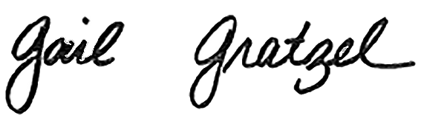
Gail Gratzel, MPH
Assistant Health Officer

